Copy and paste the information below, and share with your manager.

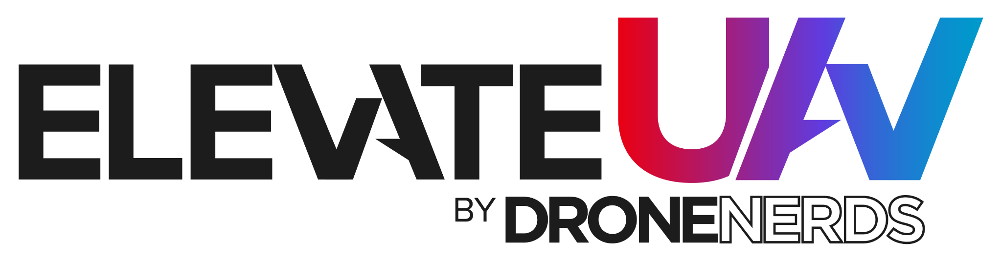
Convince Your Boss Letter

Dear <Insert Manager’s Name>:

I’m writing to request your approval to attend EUAV 2024. Drone Nerds is hosting a premier drone conference that will take place at the FIU Kovens Center in Miami, FL on October 8-10, 2024, and I think it could be an amazing learning and growth opportunity for me.

Why ElevateUAV? It’s the ultimate drone summit in which top manufacturers, thought leaders and industry experts come together to discuss the advancements of UAV technology and how it’s helping modernize businesses throughout key industries worldwide. ElevateUAV is a unique opportunity for me to learn about new technology that can help drive a competitive edge for our business by:

● Expert-led sessions that will provide key insights and trends crucial to my work and beyond. I’ll walk away from the conference with new tactics that I can immediately put to use to scale our operations.

● An inspiring lineup of speakers who will share their expertise and offer new perspectives to tackling work challenges by leveraging UAVs.

● A global and diverse community of attendees to build new relationships with; since EUAV is attended by folks throughout various industries and professions, I’ll be able to network with industry leaders and peers from a wide variety of companies and industries that can lead to new partnerships, collaborations, business opportunities, and more.

ElevateUAV unites thought leaders from all over and I’ll be able to choose my own learning path with purpose-driven sessions and other event experiences based on my growth goals and interests.

Here’s the approximate breakdown of costs for me to attend:
In-person passes General Admission $<Insert current price>
VIP PASS $<Insert current price>
Hotel: $<Insert current price>
Other Travel Expenses: $<Insert price>

Total: $<Insert Total>
I hope you agree that this will be a great opportunity for me to bring back new ideas and methods that will ultimately benefit our organization. Upon my return, I’ll be ready to share key takeaways, including practices we can start to implement immediately.

Thank you for your consideration!
<Insert Name>

